**MODULE 3 – Introduction to Business Of EV**

3.2 Electrification, A Sustainable disruption

Practice Problems

### Question 1 Which statement(s) is/are made in the article *The Future of Mobility* given in the lecture notes?

1. More people die from poor outdoor air quality, which is significantly caused by road traffic, than from road accidents.
2. As a consequence of burning fossil-oil, road transport directly accounts for about 50% of the CO2 emissions in Europe.
3. Constant noise emission from traffic causes 60.000 citizens of Dutch city Rotterdam health problems.

Ans. A

### Question 2 Please take a look at the picture below and answer the question.

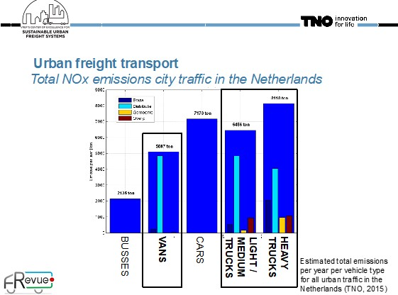

In the figure above, you can see that buses and city trucks (light and medium trucks) cause less pollution than passenger cars but still we consider the initiatives of zero emission buses and zero emission city logistics in the Netherlands to be a sensible decision. Why?

1. Passenger cars are not the main polluters because the total kilometers driven by cars is more than the others. City buses have relatively high impact than cars because these buses drive only 5% of the kilometers in the city and still cause a significant part of the pollution. Also, such initiatives mean clean air and that is directly important for life expectancy.
2. Total kilometers driven by the cars are less than the City buses. Therefore, cars have relatively high impact than buses. Also, such initiatives mean clean air and that is directly important for life expectancy. Therefore, zero emission buses and zero emission city logistics in the Netherlands is a sensible decision.

Ans. A

### Question 3 The below figure represents a type of study.

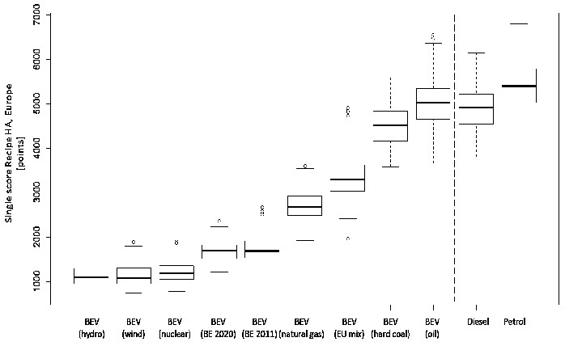

What is this type of study called? What does a high eco-score mean?

1. The figure represents Assessment Cycle. Getting a high score means low impact. Therefore, the diesel/petrol engine have a higher environmental impact and on average cause more pollution than Battery Electric Vehicles.
2. The figure represents Feasibility Study. Receiving a low score means high impact. Therefore, the diesel/petrol engine have a lower environmental impact and on average cause more pollution than Battery Electric Vehicles.
3. The figure represents Life Cycle Assessment Study. A high score means high impact. Therefore, the diesel/petrol engine have a higher environmental impact and on average cause more pollution than Battery Electric Vehicles.

Ans. C

### Question 4 The following figure shows the distribution of raw energy use.

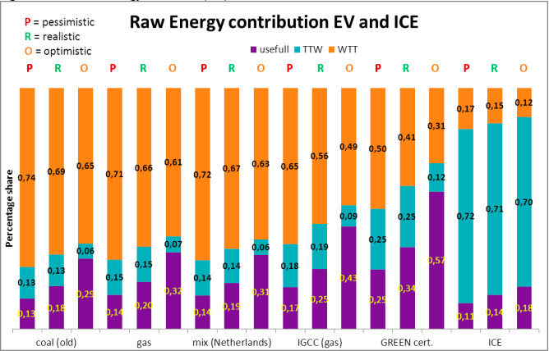

Read the statement below, then answer whether it is true or false.

*Based on the figure above, the difference between the pessimistic and optimistic case of useful energy from coal is more than a quarter.*

The above statement is

1. True
2. False

Ans. B